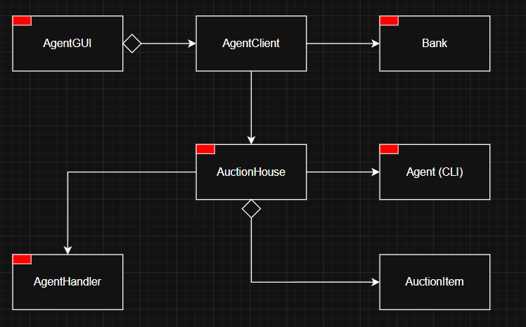

Agent: A command-line client that connects to the bank and auction houses to view items and place bids.
AgentClient: A networking abstraction that handles all communication between the agent and the bank or auction houses.
AgentGUI: A graphical interface that allows users to interact with the auction system through the AgentClient.
AuctionHouse: A Server that manages auction items, processes bids from agents, and coordinates fund operations with the bank.
AgentHandler: A threaded handler that manages communication and bidding actions for a single connected agent.
AuctionItem: A data object representing an item being auctioned, including its description, minimum bid, and current highest bid.
Bank: A centralized server that manages accounts, tracks balances, and handles fund blocking, unblocking and transfers.

